Buzz word

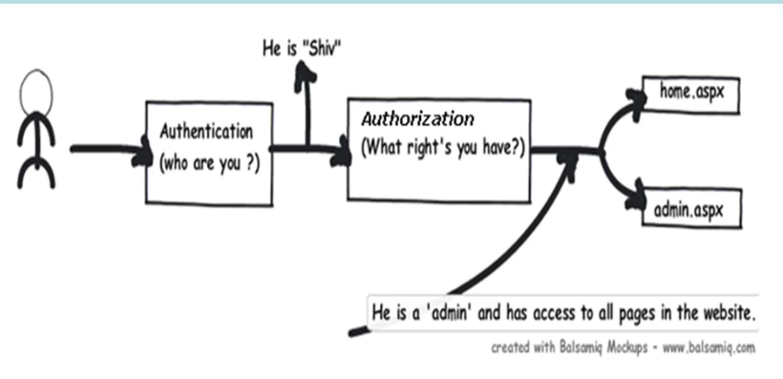

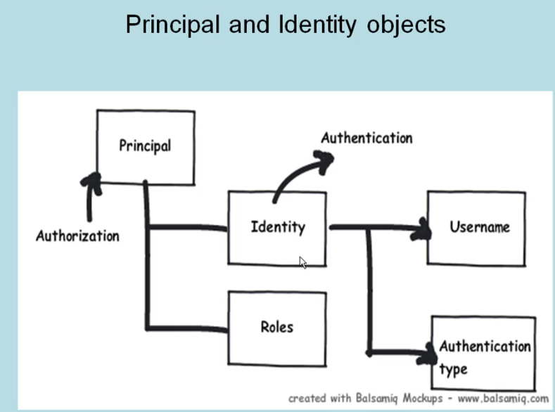

Windows Authentication:

Here the credentials are taken from the local system active directory for the authentication purpose normally used for intranet websites

Forms authentication:

Cookie based authentication where username and passwords are saved in cookie file on client machine.

Browser doesn’t support cookie every time send credentials as a part of url

We can have our own Forms for entering the credentials.

Passport authentication: Done based on the passport website providers like live, oulook,. Hotmail

When credentials reached the passport site it validate the credentials if the authentication is successful token will be generated and sent to our website.

Anonymous :

No security nobody can access with url.

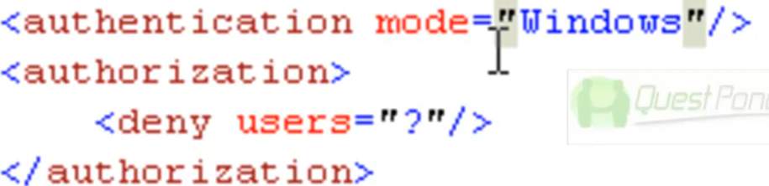

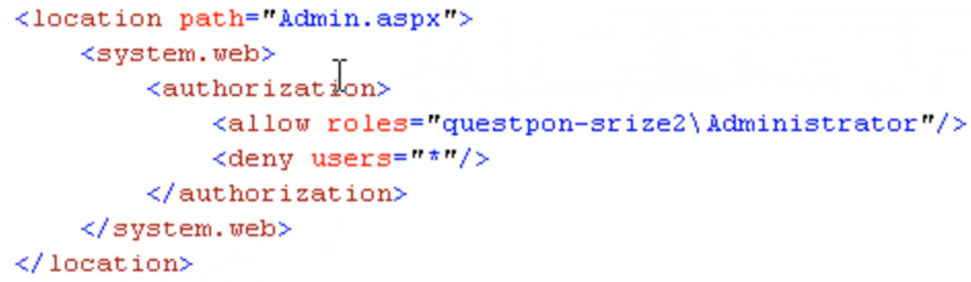

Authentication modes:

In all the type basic difference is that how the windows credentials are copied or taken when the request is made to the web page.

Basic authentication:

Credentials are passed as based 64 encoded text which can be easily decripted.

Digest authentication uses MD5 Algorithms encrypt the data Problem is not supported in most of the browser

Integrated widows authentication: